**Activity Diagram**

This part of the document presents the flow of the project using an object-oriented flowchart. Its purpose is to capture the dynamic behavior of the system. It focuses on the execution and flow of the behavior of a system instead of implementation.

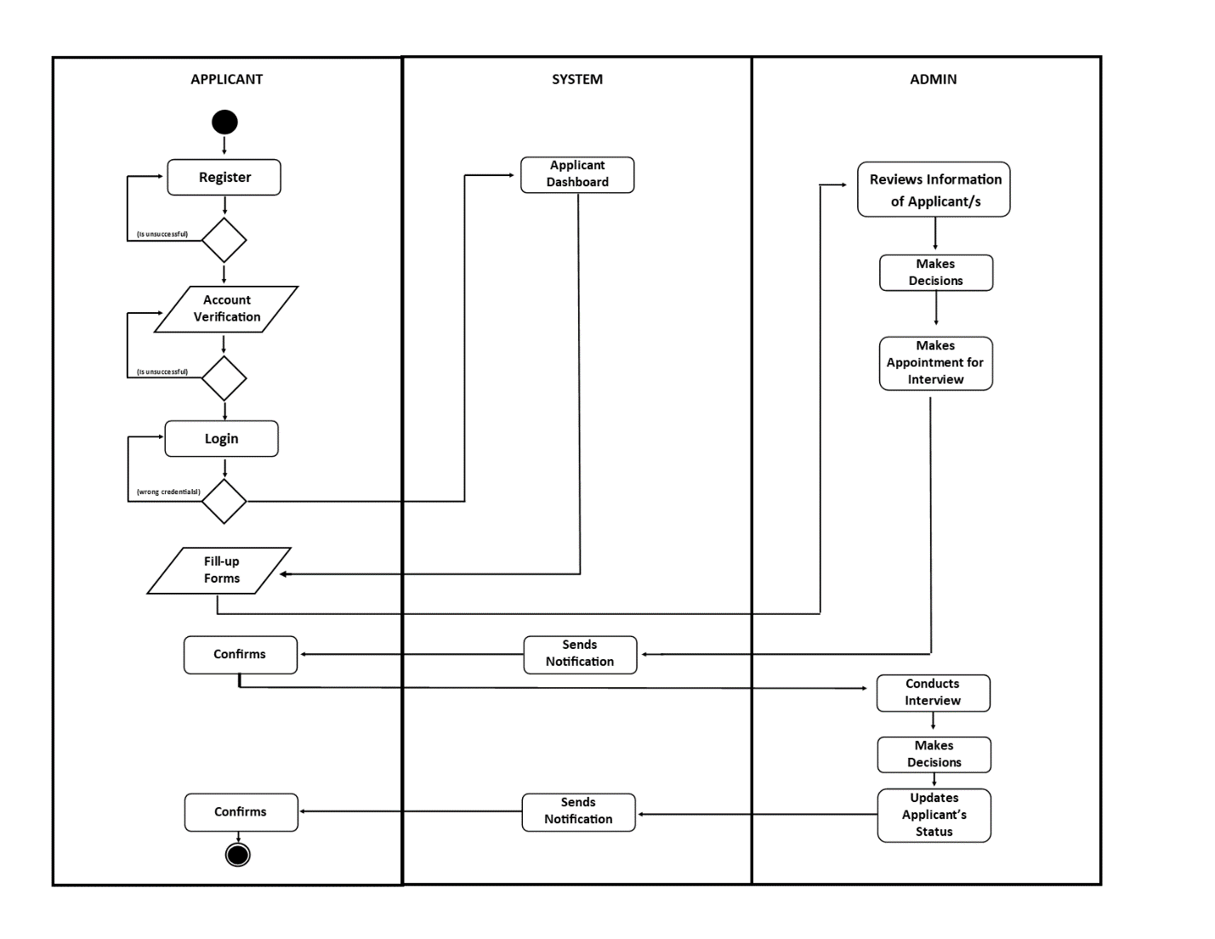

**Figure No.(Number) Activity Diagram**

Figure (number) shows, the activity diagram of the system wherein the applicants will register then login their accounts, after that they will fill-up the forms and the information will be sent directly to the administrator. The administrator will then review their information and makes the decision if the applicant is valid for interview, the administrator will make an appointment and then the system will notify the applicant for the interview and the applicant will confirm it. The administrator will then conduct the interview, after the interview the administrator will again decide if the applicant is good for the job, if the applicant is accepted, the administrator will update the applicant’s status, the system will send the notification to the applicant and the applicant will confirm it.

**Data Flow Diagram**

The data flow diagram, which functions similarly to a map to depict the information flow for all system processes, is presented next.

**Context Diagram**

**Figure No. (Number) Context Diagram**

Figure (Number) shows the development on how the proposed system will work and function in the respective areas and specific users that they are designed to work on.

**Diagram 0**

The Diagram 0 of E-Recruit: An Online Recruitment System for Insurance and Investment Agency in Mindoro shows the flow of information to visualize the process of the project.

**Figure 3: DFD Level 0**

Figure 3: DFD Level 0 illustrates the interactions and data flows between the Admin, Agents, and Applicants.

**Implementation Plan**

If the proposed system is adopted by certain people, the researchers have devised an implementation strategy. If this is the case, the system as well as its documentation will be turned over. It will be used as a guide for the client who will oversee system updates and maintenance. There should be a letter of agreement stating that the system is freely given to the user and that the researchers will not be responsible for the project's updating and maintenance. If the initiative is approved, the researchers are planning to conduct several strategies.

**Table (Number) Implementation Plan**

|  |  |  |
| --- | --- | --- |
| **Activities** | **Date** | **Progress Note** |
| Meeting with the Client | November 5, 2023 | Agreed in the Project Proposal |
| Deployment Approval | March 7, 2024 | Approved |
| System Deployment and Monitoring Period | July 30, 2024 | Few errors and updates on the major features |
| System Evaluation | September 15, 2024 | Client was satisfied |